Project Design Phase-II
Technology Stack (Architecture & Stack)

Date | 31 January 3035
Team ID
Project Name
Maximum Marks | 4 Marks

Technical Architecture:
The Deliverable shall include the architectural diagram as below and the information as per the table1 & table 2
Example: Order processing during pandemics for offline mode
Guidelines:
1. Commuter submits source, destination & ticket count
2. Catalog submission passes validated data to flow designer
3. Flow designer generates record ID, sends to QR generator
4. Booking & status are written to D1/D2 data stores
5. QR ticket is issued and read by the gate scanner
6. Admin queries data stores for booking reports
Dashed side line: external payment gateway API call. No ML/AI model interface in this workflow.
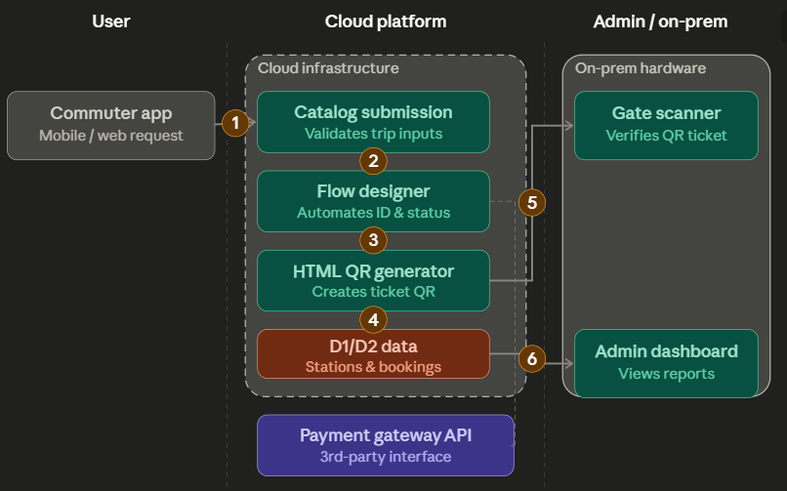

Table-1 : Components & Technologies:
S.No | Component | Description | Technology
 | User Interface | How user interacts with application e.g.  Web UI, Mobile App, Chatbot etc. | HTML, CSS, JavaScript / Angular Js / React Js etc.
 | Application Logic-1 | Logic for a process in the application | Java / Python
 | Application Logic-2 | Logic for a process in the application | IBM Watson STT service
 | Application Logic-3 | Logic for a process in the application | IBM Watson Assistant
 | Database | Data Type, Configurations etc. | MySQL, NoSQL, etc.
 | Cloud Database | Database Service on Cloud | IBM DB2, IBM Cloudant etc.
 | File Storage | File storage requirements | IBM Block Storage or Other Storage Service or Local Filesystem
 | External API-1 | Purpose of External API used in the application | IBM Weather API, etc.
 | External API-2 | Purpose of External API used in the application | Aadhar API, etc.
 | Machine Learning Model | Purpose of Machine Learning Model | Object Recognition Model, etc.
 | Infrastructure (Server / Cloud) | Application Deployment on Local System / Cloud  Local Server Configuration:  Cloud Server Configuration : | Local, Cloud Foundry, Kubernetes, etc.

Table-2: Application Characteristics:

S.No | Characteristics | Description | Technology
1 | Open-Source / Web Frameworks | Lightweight HTML container rendering and REST API integration | Web REST APIs, HTML/CSS
2 | Security Implementations | Access control lists (ACLs) restricting ticket modification and role-based access | ServiceNow Access Control Lists (ACLs) & Role-Based Access (RBAC)
3 | Scalable Architecture | Cloud-native multi-tenant SaaS architecture supporting concurrent ticket bookings | ServiceNow SaaS Cloud Platform Architecture
4 | Availability | High availability with redundant cloud server infrastructure and 24/7 uptime | ServiceNow High Availability (HA) Multi-Instance Architecture
5 | Performance | Optimized query execution using reference fields (Display = true) and asynchronous client scripts | ServiceNow Indexing & Asynchronous Client Scripting

